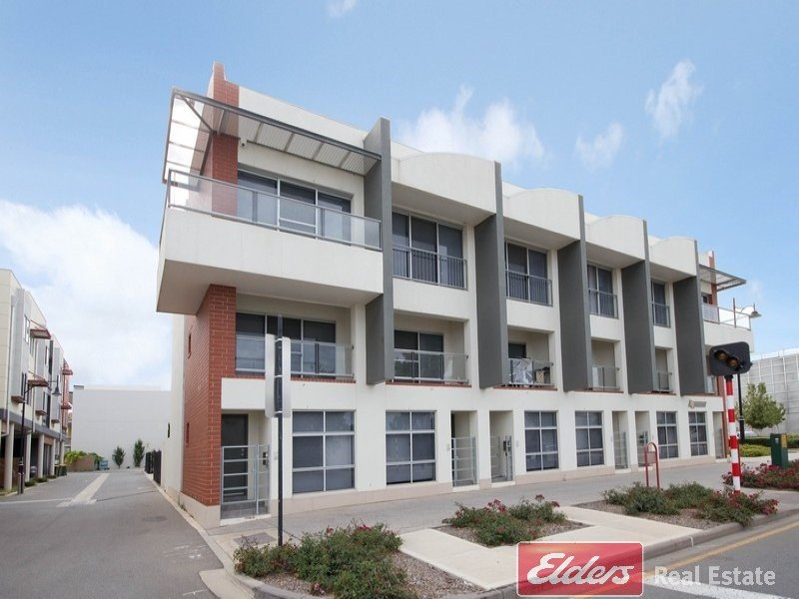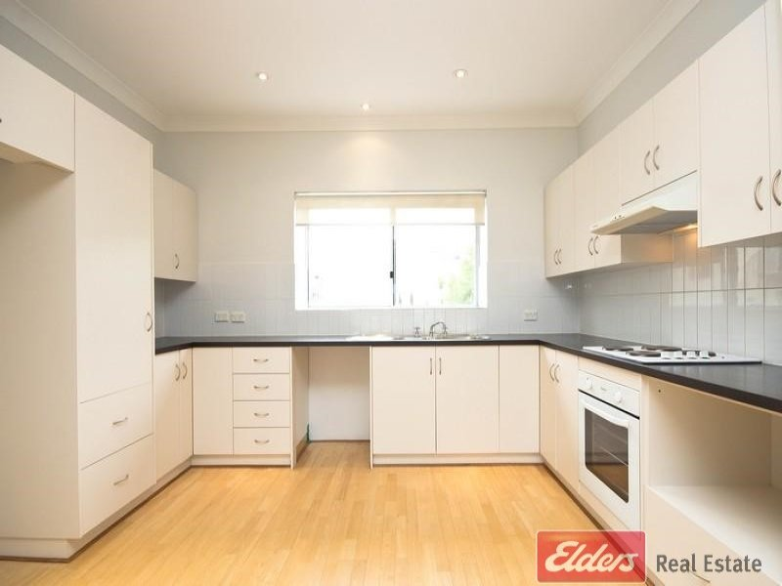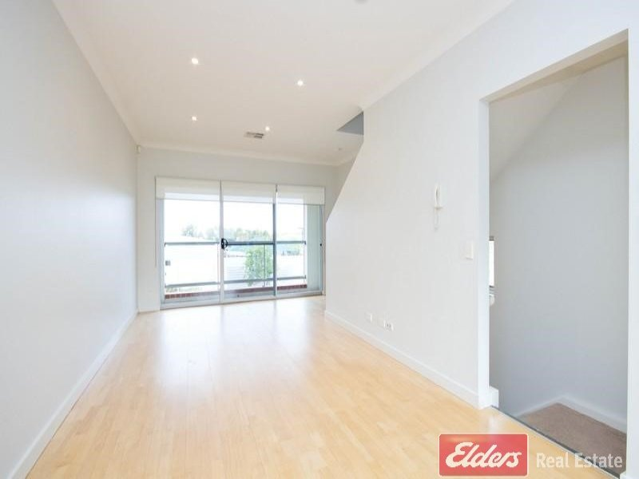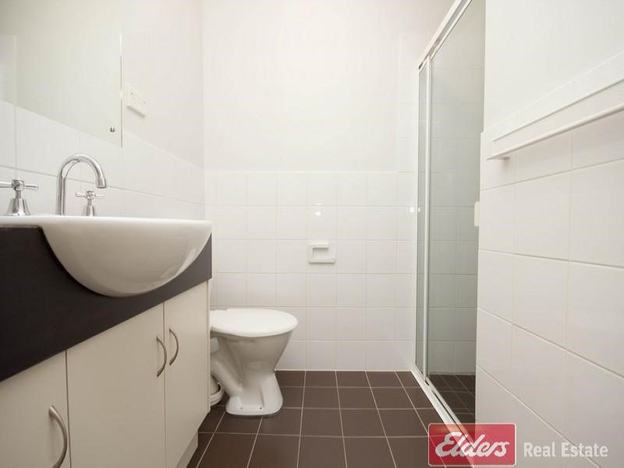

- two generous bedrooms on upper level  
- ensuite bathroom and built in robes to main bedroom  
- second bathroom on upper level  
- middle level comprising open plan living, kitchen and balcony.  
- Generous kitchen with plenty of cupboard space and quality electric appliances  
- lower lever comprising third bedroom, Urban laundry, third toilet and single lock up garage